**DAY 4**

**NETWORKING**

------------------------------

**OSI:OPEN SOUCE INTERCONNECTION**

The OSI model is a way to understand how different computer systems communicate over a network. It breaks down the communication process into seven layers, each with a specific job. Think of it like a seven-step recipe for sending data from one computer to another. Here's a simple breakdown:

1. **Physical Layer:** This is the first step where the data is turned into electrical signals and sent through cables or wireless connections. It's like turning your words into sound waves when you talk
2. **Data Link Layer:** This step makes sure the data is error-free as it travels from one device to another within the same network. It's like making sure your letter is correctly addressed and stamped before sending it.
3. **Network Layer:** This layer decides the best path for the data to travel across different networks to reach its destination. It's like planning the best route for a road trip.
4. **Transport Layer:** This step ensures that the entire message gets to the destination without any errors and in the right order. It's like making sure all the pages of your letter are in the right order and none are missing.
5. **Session Layer:** This layer manages the start, maintenance, and end of the communication session between two devices. It's like starting, maintaining, and ending a phone call.
6. **Presentation Layer:** This step translates the data into a format that the application layer can understand. It also handles encryption and compression. It's like translating a book into a language you understand.
7. **Application Layer:** This is the final step where the data is used by software applications like web browsers or email programs. It's like reading the letter you received.

Each layer only interacts with the layer directly above and below it, making the whole process organized and efficient. This model helps different technologies and products work together smoothly.

## ****OSI Model – Layer Architecture****

| **Layer No** | **Layer Name** | **Responsibility** | **Information Form (Data Unit)** | **Device or Protocol** |
| --- | --- | --- | --- | --- |
| **7** | [Application Layer](https://www.geeksforgeeks.org/open-systems-interconnection-model-osi/" \l "application-layer-layer-7" \t "https://www.geeksforgeeks.org/open-systems-interconnection-model-osi/_blank) | Helps in identifying the client and synchronizing communication. | Message | [SMTP](https://www.geeksforgeeks.org/simple-mail-transfer-protocol-smtp" \t "https://www.geeksforgeeks.org/open-systems-interconnection-model-osi/_blank) |
| **6** | [Presentation Layer](https://www.geeksforgeeks.org/open-systems-interconnection-model-osi/" \l "presentation-layer-layer-6" \t "https://www.geeksforgeeks.org/open-systems-interconnection-model-osi/_blank) | Data from the application layer is extracted and manipulated in the required format for transmission. | Message | [JPEG](https://www.geeksforgeeks.org/jpeg-full-form" \t "https://www.geeksforgeeks.org/open-systems-interconnection-model-osi/_blank), [MPEG](https://www.geeksforgeeks.org/mpeg-full-form" \t "https://www.geeksforgeeks.org/open-systems-interconnection-model-osi/_blank), [GIF](https://www.geeksforgeeks.org/what-is-a-gif-file" \t "https://www.geeksforgeeks.org/open-systems-interconnection-model-osi/_blank) |
| **5** | [Session Layer](https://www.geeksforgeeks.org/open-systems-interconnection-model-osi/" \l "session-layer-layer-5" \t "https://www.geeksforgeeks.org/open-systems-interconnection-model-osi/_blank) | Establishes Connection, Maintenance, Ensures Authentication and Ensures security. | Message (or encrypted message) | [Gateway](https://www.geeksforgeeks.org/what-is-circuit-level-gateway" \t "https://www.geeksforgeeks.org/open-systems-interconnection-model-osi/_blank) |
| **4** | [Transport Layer](https://www.geeksforgeeks.org/open-systems-interconnection-model-osi/" \l "transport-layer-layer-4" \t "https://www.geeksforgeeks.org/open-systems-interconnection-model-osi/_blank) | Take Service from Network Layer and provide it to the Application Layer. | Segment | [Firewall](https://www.geeksforgeeks.org/introduction-of-firewall-in-computer-network" \t "https://www.geeksforgeeks.org/open-systems-interconnection-model-osi/_blank) |
| **3** | [Network Layer](https://www.geeksforgeeks.org/open-systems-interconnection-model-osi/" \l "network-layer-layer-3" \t "https://www.geeksforgeeks.org/open-systems-interconnection-model-osi/_blank) | Transmission of data from one host to another, located in different networks. | Packet | [Router](https://www.geeksforgeeks.org/introduction-of-a-router" \t "https://www.geeksforgeeks.org/open-systems-interconnection-model-osi/_blank) |
| **2** | [Data Link Layer](https://www.geeksforgeeks.org/open-systems-interconnection-model-osi/" \l "data-link-layer-layer-2" \t "https://www.geeksforgeeks.org/open-systems-interconnection-model-osi/_blank) | Node to Node Delivery of Message. | Frame | [Switch](https://www.geeksforgeeks.org/what-is-a-network-switch-and-how-does-it-work" \t "https://www.geeksforgeeks.org/open-systems-interconnection-model-osi/_blank), [Bridge](https://www.geeksforgeeks.org/what-is-bridge-in-computer-network-types-uses-functions-differences" \t "https://www.geeksforgeeks.org/open-systems-interconnection-model-osi/_blank) |
| **1** | [Physical Layer](https://www.geeksforgeeks.org/open-systems-interconnection-model-osi/" \l "physical-layer-layer-1" \t "https://www.geeksforgeeks.org/open-systems-interconnection-model-osi/_blank) | Establishing Physical Connections between Devices. | Bits | [Hub](https://www.geeksforgeeks.org/what-is-network-hub-and-how-it-works" \t "https://www.geeksforgeeks.org/open-systems-interconnection-model-osi/_blank), [Repeater](https://www.geeksforgeeks.org/repeaters-in-computer-network" \t "https://www.geeksforgeeks.org/open-systems-interconnection-model-osi/_blank), [Modem](https://www.geeksforgeeks.org/what-is-modem" \t "https://www.geeksforgeeks.org/open-systems-interconnection-model-osi/_blank), Cables |

**TCP:TRASMISSION CONTROL PROTOCOL**

TCP/IP, which stands for Transmission Control Protocol/Internet Protocol, is the basic communication language or protocol of the internet. It helps computers communicate over long distances and across different networks. Here’s a simple way to understand it:

**TCP (Transmission Control Protocol):**

**Purpose:** Makes sure data is sent and received correctly.**How it works:** It breaks data into small pieces called packets. Each packet is sent separately and then reassembled at the destination. TCP checks for errors and ensures that all packets arrive and are in the right order.

**IP (Internet Protocol):**

**Purpose:** Handles the addressing and routing of packets to make sure they reach the correct destination.**How it works:** Every device on the internet has an IP address (like a postal address). IP directs the packets to the correct address.

**Putting It Together:**

* **Example:** When you send an email, TCP divides it into packets, numbers them, and sends them off. IP ensures each packet is routed to the recipient's IP address. When all packets arrive, TCP reassembles them into the original email.

**OSI vs TCP/IP**

**OSI :** A theoretical framework to help understand how different network systems communicate

**TCP :** A practical framework used for real-world network communication, especially on the internet.

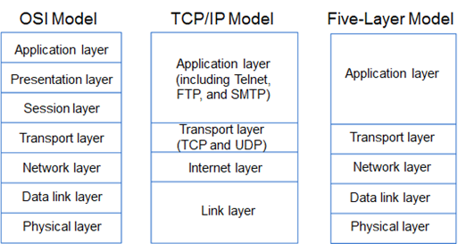

**PORT NUMBER : A** port number is like a door number on a building, but for network communication. It's a numerical identifier used by network protocols to distinguish different services or applications running on a single device.

Port numbers range from 0 to 65535.

· 80 for HTTP (web browsing)

· 443 for HTTPS (secure web browsing)

· 25 for SMTP (email sending)

· 22 for SSH (secure remote access)

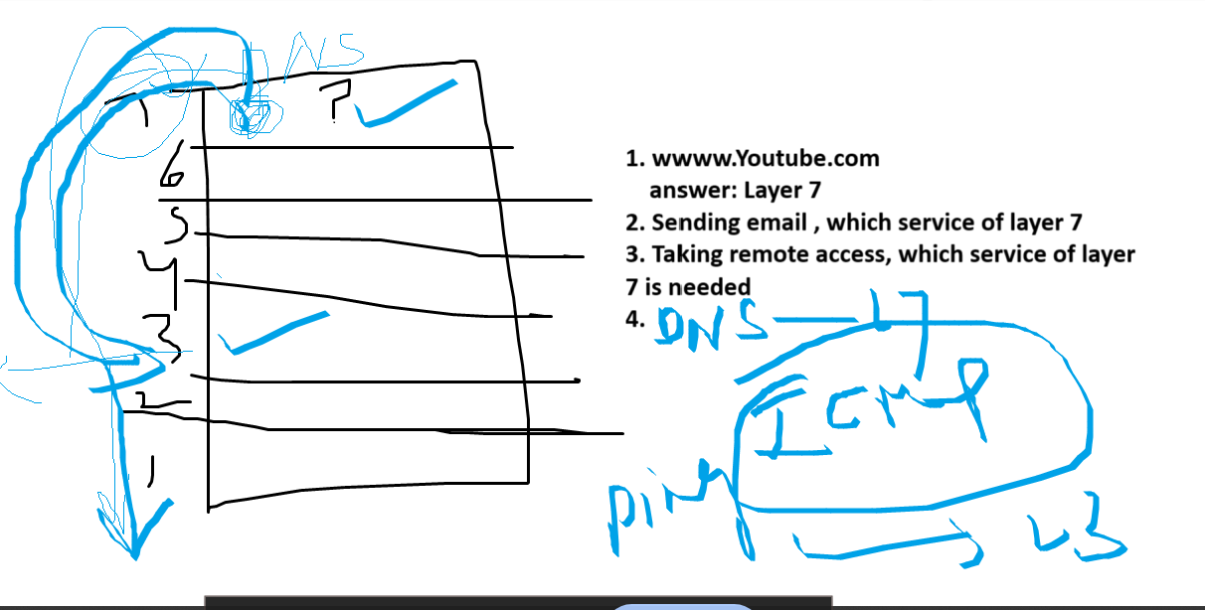

1.for webserach we need port number 443 for HTTPS in layer 7

1. for sending an email we need port number 25 for SMTP in layer 7
2. Taking remote access we need port number 22 for SSH in layer 7
3. Dns we need port number 53 for in layer 7

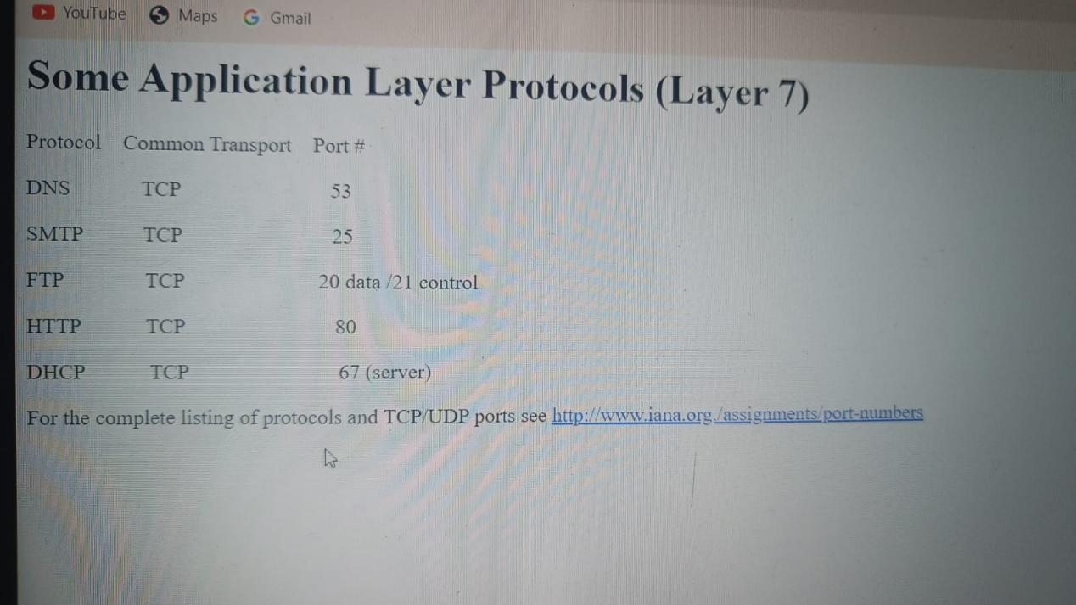

**NAT LAB**

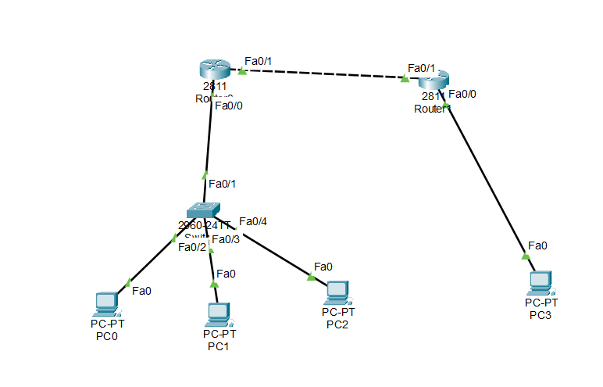

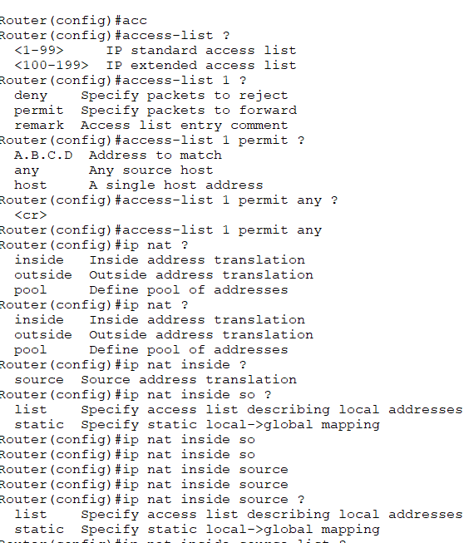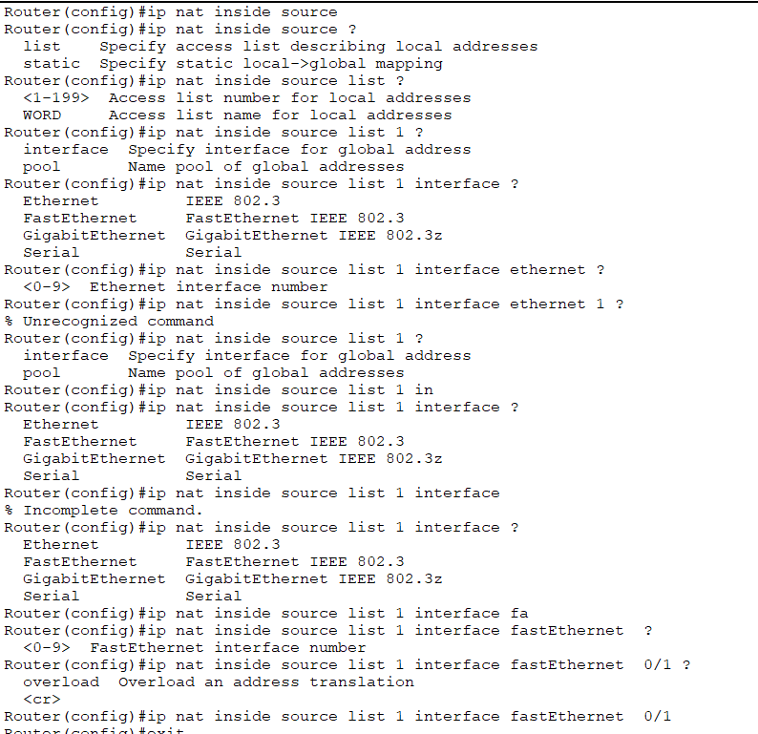

**interface FastEthernet0/1 ,ip nat outside,Exit , interface FastEthernet0/0,ip nat inside**

